Project Design Phase-I Problem Solution Fit

|  |  |
| --- | --- |
| Date | 16 November 2022 |
| Team ID | PNT2022TMID45099 |
| Project Name | Project - Customer Care Registry |
| Marks |  |

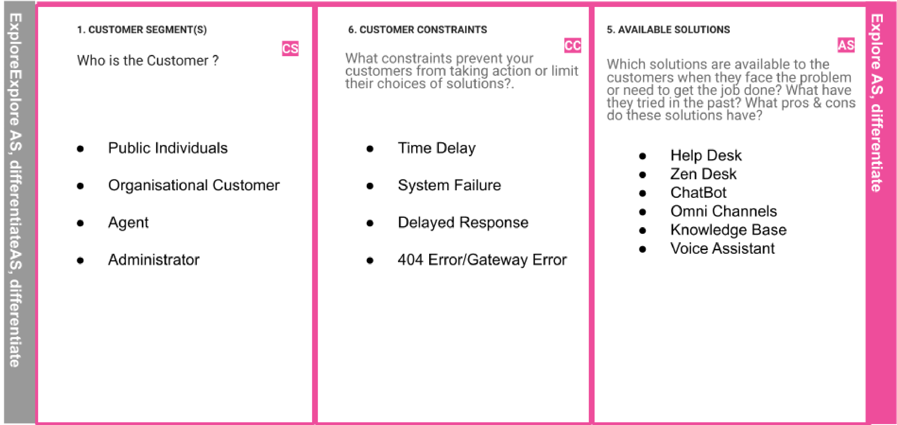

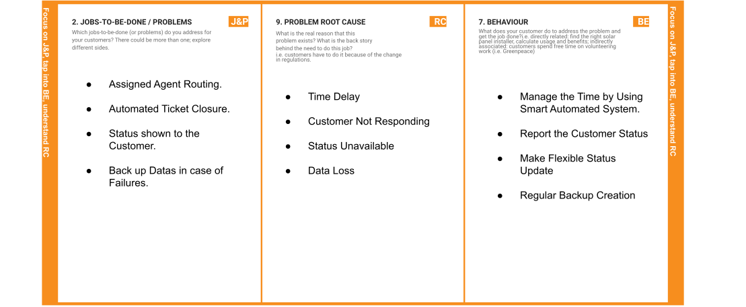

|  |  |  |  |  |
| --- | --- | --- | --- | --- |
|  | 3. TRIGGERS  TR  What triggers customers to act?  Quick Resolving Issues and Smart  Status Tracker | 10. YOUR SOLUTION  SL  If you are working on an existing business, write down your current solution first, fill in the canvas, and check how much it fits reality.  If you are working on a new business proposition, then keep it blank until you fill in the canvas and come up with a solution that fits within customer limitations, solves a problem and matches customer behavior.   * Ticket Booking through Automation Routing. * Looking for Status of the Available Tickets. * Solving Problems as a Customer is Unavailable. * Back Up Data as a Regular Restoring | 8.8 CHANNELS of BEHAVIOR CH  8.1 ONLINE  What kind of actions do customers take online? Extract online channels from #7  Approach to the best Solvable Expert from the Available Existing Applications or Search for the best Suitable Solution from the Social Media Recommendations.  8.2 OFFLINE  What kind of actions do customers take offline? Extract offline channels from #7 and use them for customer development.  Mostly looking into Online for the solving the issue is better because offline turns to be high time consuming as well have many failure cases as the Customers approach is very new. |  |
| 4. EMOTIONS: BEFORE / AFTER  EM  How do customers feel when they face a problem or a job and afterwards?  They feel Anxiety,Frustrated and Stressed as it is a Critical or Emergency Situation to bring a Good Solution. |